

CIS C290

M06 Assignment: Unsupervised Learning

Part 1. Using the shoppers.csv file, run k-Means cluster analysis by shopper annual_income_k and spending_score. Include the centroid. Write 3-4 sentences describing the data results. Include a screenshot of the Python output.

Based on the Elbow Method, we can find the optimal number of clusters(k) to form the k-means clusters. Find k by finding the number of clusters in the elbow method graph and finding the value where the wcss starts to have a horizontal line, which in this case, it is close to 5 and find the clusters using k equals to 5. The cluster visualization suggests that the clusters have been formed and can clearly distinguish between the different clusters, suggesting that the shoppers can be split into roughly 5 groups that scatter all over the graph. This suggests that the annual income is not a significant predictor.
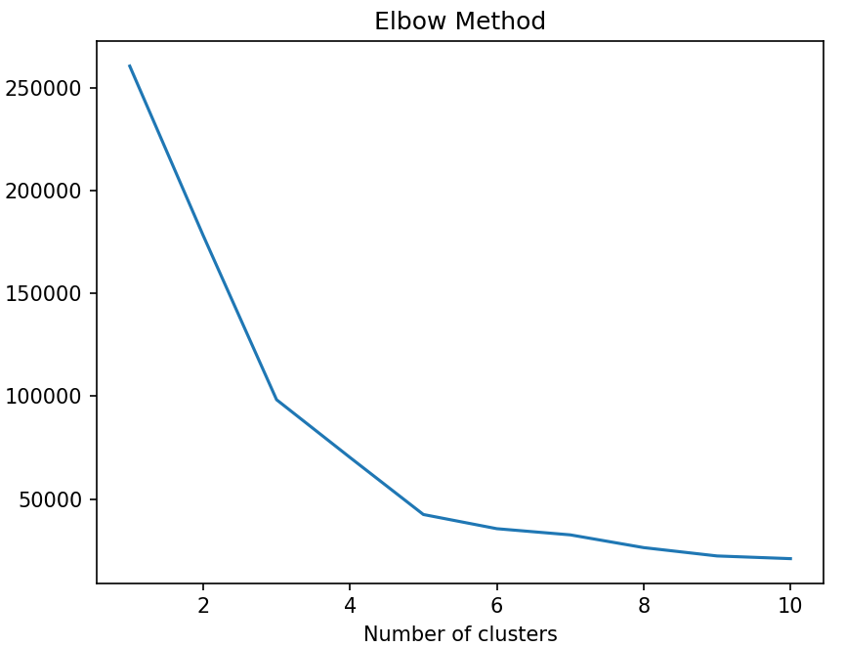
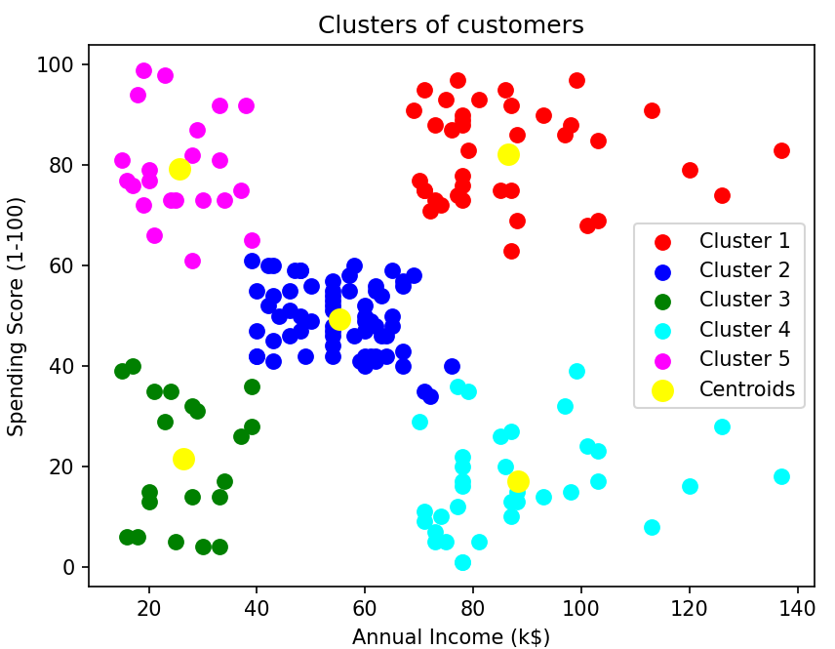
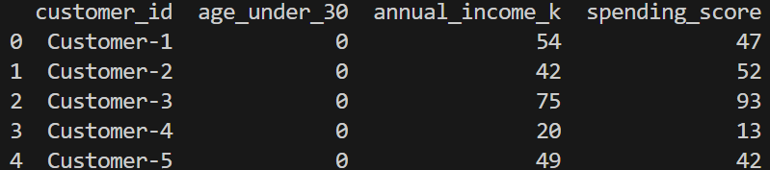

Part 2. Using the Market_Basket.csv file, run an Apriori Algorithm or Market Basket Analysis and write 3-4 sentences describing the data results. Include a screenshot of the Python output.

Based on the output metrics, the relationships of purchasing one item have a low chance of purchasing another item, with all the relationships shown having low confidence (< 40%). This result is not a random change as specified by the lift metric (> 3.9). However, all of the shown relationships are only a small portion of the dataset, which suggests the threshold might be too high or the dataset might be too large.
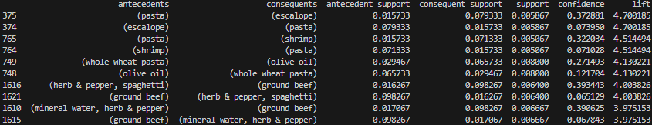

Part 3. In a minimum of 3 sentences, describe your experience with the assignment. Indicate which resources you used.

During part 2 of the assignment, I had a struggle with the preprocessing for the Apriori application since the csv specified doesn’t seem to have a title row. This resulted in the lab’s exercise needs to be adjusted for proper analysis, which I fixed through some research in pandas documentation and google.

